**Smart Plant Monitor**

Project for: EE250

Gro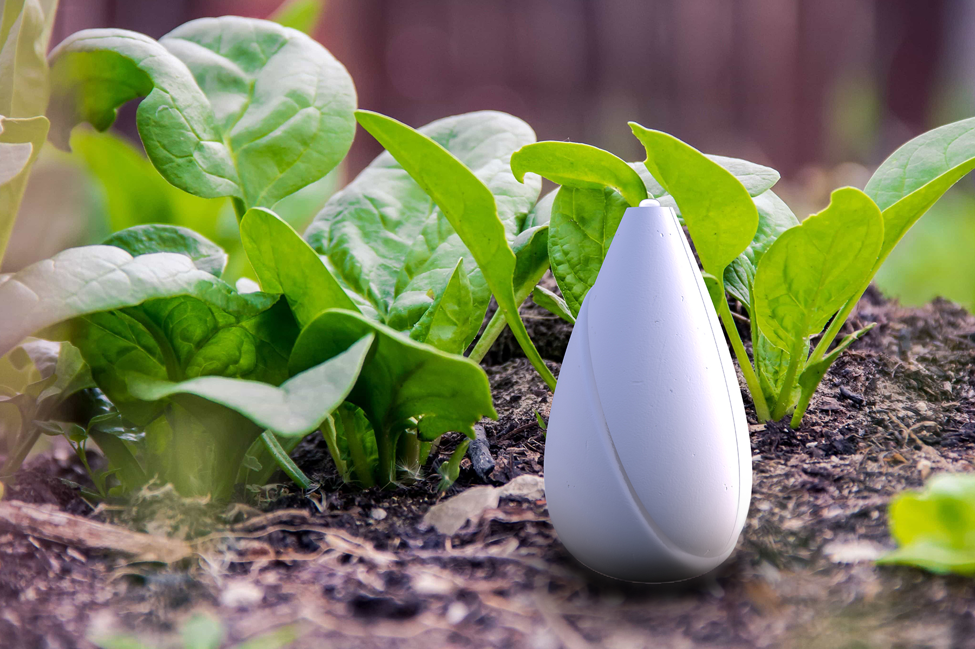up members: Tianyi Yang, Horace Xu

EE250 Spring 2021

April 30, 2021

# Executive Summary

## Description and Objective

The main objective of our IoT system is to provide a smart solution to monitor and help the growth of plant. Our project will take measurement of ambient light, temperature, humidity, record the data and visualize the data using plots. In addition, the system will notice the user if the plant needs water and supplement light through LEDs when the sunlight intensity drops down to a limit.

We wanted to build a product that addresses the environmental concerns. Many people love to keep a plant at home or at school. Our product can help with keeping track of when to water and how much water to use each time. This system can also be implemented outdoors to protect trees and forests. In the meanwhile, agriculture business need an IoT system that can help with irrigation while monitor the ambient environment for crops. Our idea is to incorporate these related functionalities into one smart product that has lightweight overhead, well-suited remote control and low cost.

## Ethics and Economics

The ethical issue lies in privacy. In order to support wireless data transmission and communication, the product has the risk of security breach. However, the sensors we use have simple functions and the data collected does not reveal any private information of the users, so the current system does not have serious privacy concerns to worry about. In future deployment we might setup firewalls to protect individual devices from attacks that affect their availability.

Smart Plant monitor

From an economic perspective, our product is already one of the most inexpensive product compare to existing solutions on the market. Some popular plant monitors sell at around $30 which is similar to the cost of our product. However, because we used the Raspberry PI that supports WIFI, the data can be transmitted to online database and used for big data processing and machine learning. Therefore, if it were deployed in application in the future, consumers will pay for it at a competitive market price with additional features. We will also work with NGOs and research laboratories to further increase sales and reduce the cost.

## Data Analysis and Self-Directed Learning

For data analysis, we used the IoT data collected for two main functions. The first one is to demonstrate the change of ambient environment with time. This is done by visualizing the data plots on the Freeboard interface. Because data from both temperature, humidity, light sensors are time synchronous, we get a constructive image of the environment and its historical change. We can further analyze what are the optimal conditions for the plant based on this. Another use of the data is to determine when the plant needs water and additional light. This is another layer of data processing, because we essentially turned the analog measurements to a Boolean variable that controls the water notification and the LED switch.

Self-Directed Learning

## Protocols and Platforms

In the Smart Plant Monitor system we used a combination of protocols and platforms. Our main application layer protocol is MQTT, which we used based on the publish and subscribe model and transmit message from multiple sensors(clients) to the central server, which is the broker. We also used HTTP, based on TCP, that sends the server data to the online visualization platform called Freeboard. To communicate between the server and the clients, we used SSH protocol to allow remote login and control to the Raspberry Pi board. The datalink and physical layer protocol to support the SSH is WiFi, but we could alternatively use Ethernet.

Smart plant monitor

Our main subscriber application runs on Virtual Machine’s Ubuntu operating system, which is a Linux distribution. In

Visualization techniques:

## Components and Block Diagram

# Project reflection